Installation Instruction for the

Pressure Test Platform

1. The pressure test platform is divided into 3 parts.

At first, please unpack the package, and use a wrench to tighten the M012 screws (which are already on the platform) when assemble and connect the 3 parts together.

1. Second, please add water to the two thirds points of the water tank.
2. Third, please mount the inlet pipe, pressure test pipe on the platform.
3. Fourth, please connect the outlet pipe from sink to the water tank, and tighten it here.
4. Fifth, please insert the aviation plug of the water pump in the socket of the distribution box.
5. Sixth, please insert the aviation plug of the Pressurization Pump in the socket of the distribution box.
6. Seventh, please insert the power plug of air compressor in the socket of the distribution box.
7. Eighth, please connect the air tube of the inlet valve and pressure control valve to the pneumatic valve(As the attached picture shows)
8. Ninth, please connect the air tube of the manual operated valve to the pneumatic valve(As the attached picture shows).

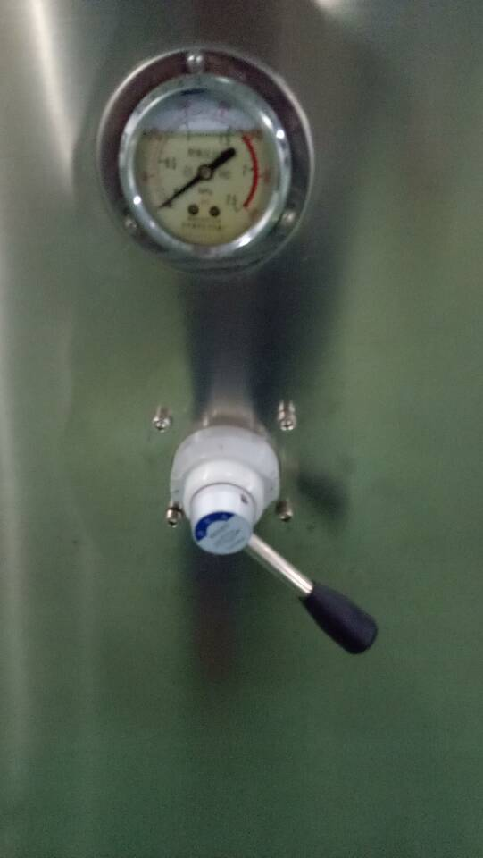 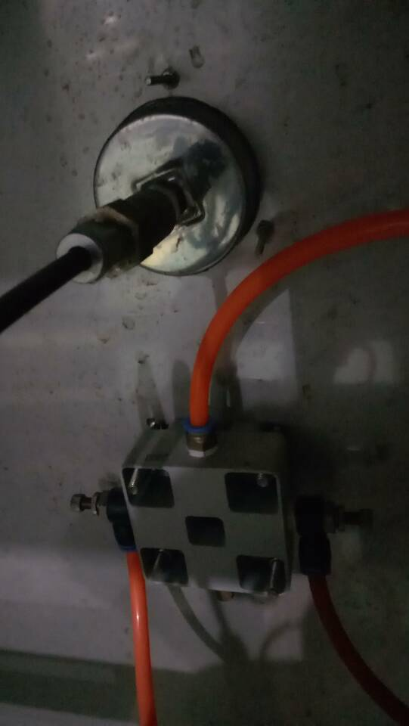

Manual Operated Valve Air Tube

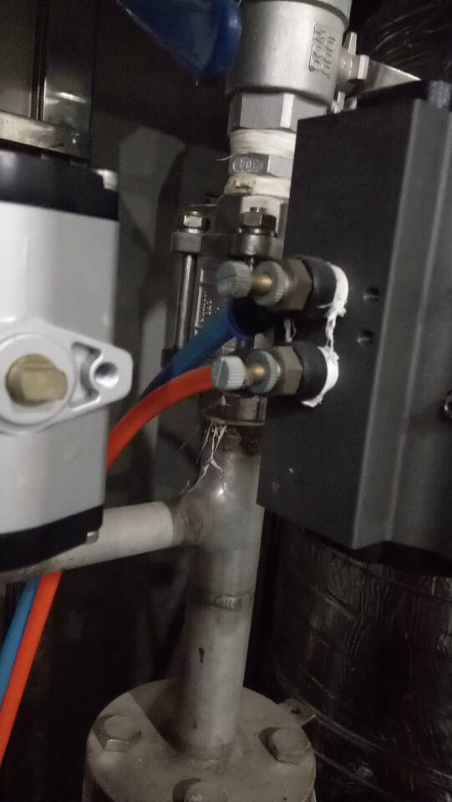

Connect the Air Tube to the pneumatic valve

1. Tenth, please insert power plug of the pressure test platform in the socket.(Note: wire should connect to the Ground)

11、At last, Please turn on the power, and choose “Manual” on the interface of Manual/Automatic, then turn on the water pump for 20 minute(Please make sure there is no leakage)

Installation is done!